Capturing the right stakeholders and concerns:

Question 1 | State your stakeholder role. List the set of concerns you have that pertain to the architecture whose AD is being reviewed.
EU Claim | Privacy of the users is guaranteed. Airline should handle situation appropriate. Transparancy is important, within the system, no airline should have more influence than another.
AirFrance- KLM | Be able to get in contact with the user. Have a reporting tool to see how the airline is doing. Enter flight information to combine with the rating. Other concerns are: costs and customer satisfaction.

Question 2 | Find and record all places in the AD where your stakeholder is listed as being covered.
EU Claim | -
AirFrance- KLM | –
 | There is no list that the concerns are being covered.

Question 3 | Find and record all places in the AD where your stakeholder is listed as being adressed.
EU Claim | Page 17: R1  Page 19: Q4, Q5  Very easy to find.
AirFrance- KLM | Page 16: F2  Page 18: M3  Functional Requirements: 5,8,9  Page 19: Q1, Q2, Q3  Very easy to find.

Question 6 | Record all concerns you have that are not listed as being covered in either the AD or any framework being used or that are listed in an unclear fashion.
EU Claim | Privacy/security concerns are clearly stated in the document. Transparency can be found at Q4. Privacy not entirely if the admin can see al the data (not clear what the admin can / cannot do)
AirFrance- KLM | Everything is stated in the document.

Question 7 | For each of the concers as a stakeholder, find and record the place where that concerns is adressed. Will it be satisfied by the architecture?
EU Claim | Privacy: Adressed on page 10 at Airline Rating Service Database  on page 25 at seperate users table. This concerns will probably satisfied by the architecture. The user database will be protected and located under dutch law.  Transparency: It is touched on page 15 at Filter and store and at Extract and apply. I am convinced it will be in the architecture but not in a very detailed way.
AirFrance- KLM | Usability: Page 6, “fast and easy to query” ; page 6: performance ; page 8 B2C application ; page 10: Airline Rating Serice database ; Section 2.2; page 18; functional requirements; page 19: Quality attribute Q2.  Since it is covered on a lot of difference places it will most probably be covered by the architecture.  Customer contact: Mentioned on page 19 and in the requirements, not convinced it will be in the architecture because that's the only mention found.  Cost: Page 4: vendor locking ; Page 6 Vendor locking ; It is not mentioned a lot, it probably isn't in the architecture but I'm not sure it should be. Cost more depends on what system/software you use instead of how the architecture looks (e.g. hadoop instead of storm). It could have been mentioned as a tradeoff for modiability.

Question 8 | Find and record the place in the AD that prioritizes the concerns. Why do / don't you agree?
 | There is no prioritization of the concerns. Some are mentioned in a way that they “must” or “should” be implemented. The document in general lays a high focus on how the data is handled which gives a priority to performance and scalability. It is quite logical they lay a focus on this point because it is one of the biggest concerns overal and it may have a large effect on the architecture.

Question 9 | Record important stakeholders that you are aware of and that are not listed and whose concerns are not represented in the AD
 | All the stakeholders are listed.

Question 10 | State how you know that the architecture satisfies the concerns of the missing stakeholders and where the information can be found in the AD.
 | There are no missing stakeholders.

Scenario #1: B2B – B2C decoupling
Attribute: Availability
Environment: Normal operations
Stimilus: B2B / B2C failure
Response: Without effecting other modules (if B2C then B2B and vice versa)
Architectural decision | Sensitivity point | Tradeoff | Risk | Nonrisk
Decoupling | S1 | T1
Different API | S1 | T2 |  | N1
T1: performance B2B vs performance B2C
T2: redundant code (modifiability/maintainability) vs availability
N1: Keeping the API as one still creates one point of failure for both B2B and B2C
S1: If they are in the same server and the server goes down, B2C and B2B will both go down.
Reasoning: Decoupling ensures together with the different API, if one of the B2B or B2C goes down, the other won't go down.
Architecture Diagram (red API crashes):
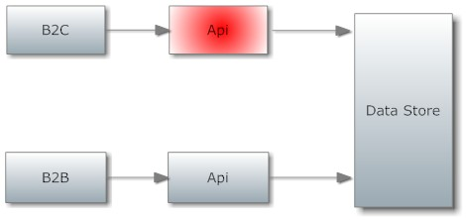

Scenario #2: Peak load on the analytics module
Attribute: Performance
Environment: Normal operations
Stimilus: Recalculation final review
Response: B2B <10 sec latency
Architectural decision | Sensitivity point | Tradeoff | Risk | Nonrisk
Recalculate 1 or 2 times a day  (implicit decision) |  |  | R1
B2B access Analytics directly (implicit decision) |  | T1
R1: Creates peakload, leads to bad availability
T1: Custom searches but there is a direct connect so if it fails of peak load it is not available
Custom search vs peak load

Reasoning: Recalculating creates a massive peakload which may therefore cause an overload which may lead to an undesirable response time. When the B2B does a custom search he will not get his answer in time.
Architecture Diagram:
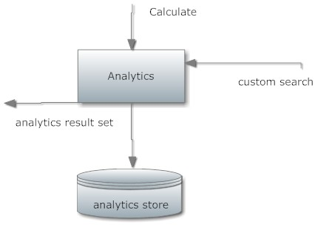

Scenario #3: Privacy of a review
Attribute: Privacy
Environment: Normal operations
Stimilus: User writes a review
Response: Anonymous review
Architectural decision | Sensitivity point | Tradeoff | Risk | Nonrisk
Logged in |  |  | R1
R1: Review is not anonymous?
Reasoning:
No where in the document is stated that a review will be shown anonymous.
Architecture Diagram:

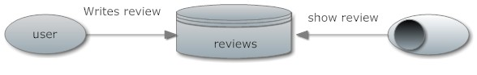
Scenario #4: Big data
Attribute: Performance, availability
Environment: Normal operations
Stimilus: Big Data input
Response: Handle all input without any loss of external reviews.
Architectural decision | Sensitivity point | Tradeoff | Risk | Nonrisk
ETL Adapters |  |  |  | N1
ETL Approaches | S1
Pipeline structure |  |  | R1
S1: If it is Big data the system can not handle the input and a choke point will occur in the pipe model.
N1: no risks
R1: Filter and store, Extract and Apply handle all reviews sequentially
Reasoning:
Because of the pipeline structure and the assumption the data is not regarded as big data the system won't be able to process more external sources when they become big data.

Architecture Diagram:
Adapter → store filter → adapter
store + adapter → database thingy

